

|  |  |  |  |  |
| --- | --- | --- | --- | --- |
| home%20is%20where%20the%20heart%20is%20art |  | |  | | --- | | Affordable Housing Newsletter: Health & Wellness  Email logo | | Well | |
|  |  |  |
|  |  |  |

**Housing Health and Wellness**

**Affordable housing provides health and wellness to the kids, teens, adults and older adults who are residents. Why? Here are a few reasons:**

* **We don’t have to choose between paying rent and buying groceries**
* **We don’t have to live in crowded or unhealthy conditions**
* **We can afford a home that provides a sense of security and community**

* **We have a stable home, and can set down roots, make connections and give back to our neighbors**
* **We learn healthy living skills from onsite social services, including practical support for financial, career, parenting and aging in place needs**

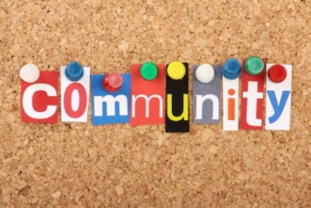

**Affordable Housing Public Policy**

**Public Policy Laws and Regulations are passed at many different levels of government. In our area, there is an affordable housing measure on the ballot this year that each voter will consider. Learn about this ballot measure and how it can help to protect money for affordable housing.**

**Sharing our Experiences**

**It is good to discuss the important political issues with neighbors and friends with respect so that everyone has valuable information. As we know, affordable housing makes communities better. But many others may not have heard about affordable housing or the positive impact it makes.**

**We can share what we know about affordable housing. Think about what affordable housing means to you. Describe how it has helped you, the opportunities it gives you now, and the impact it will have on your future.**

|  |
| --- |
| Discussion Questions: |
| What are the top 3 things about affordable housing that make your life better?  Why will affordable housing be needed by your community in the future?  Who will you discuss the Affordable Housing measure with? |

