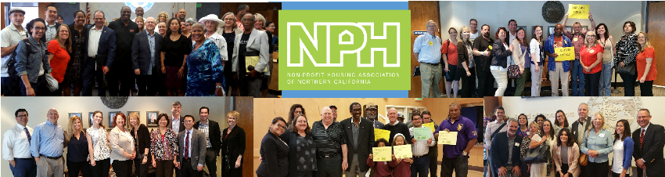

MY PLAN FOR RESIDENT ENGAGEMENT:

VOTER REGISTRATION THEN VOTER EDUCATION IN 2016

TODAY - PLANNING
Property Name | #1 | #2
On-Site Contact

# Residents (Approx)
# Registered Voters (Approx)
# Bulletin Board / Sign Placements
SUMMER THROUGH MID-SEPTEMBER – VOTER REGISTRATION
# Goal for 15% Reg. Increase
Community Mtgs?
Resident Councils?
Family classes?
Newsletters?
Special Events?
MID-SEPTEMBER THROUGH NOVEMBER 8 – CIVIC ENGAGEMENT & EDUCATION
# Goal for
Pledge to Vote Cards
# Pledges Turned In

Speakers or Presentations
Community Mtgs?
Resident Councils?
Family classes?
Newsletters?
Special Events?

