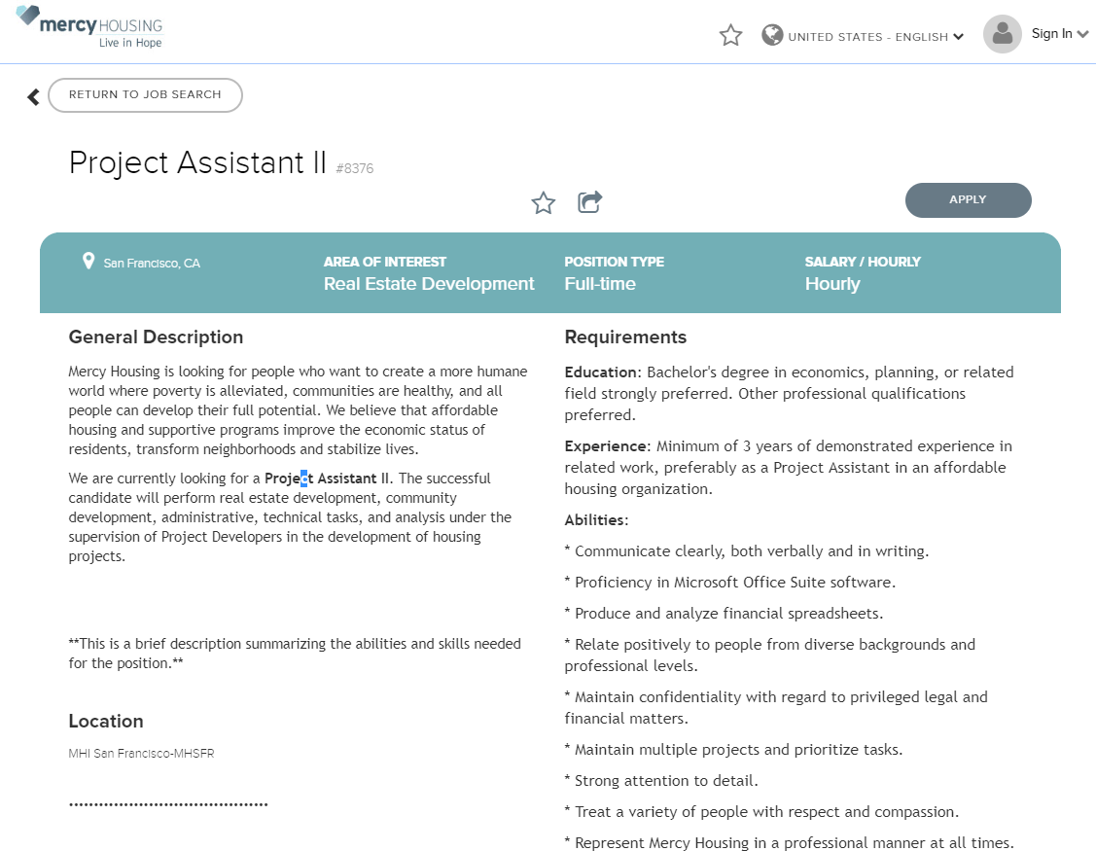
https://recruiting.adp.com/srccar/public/RTI.home?c=1211201&d=ExternalCareerSite#/

