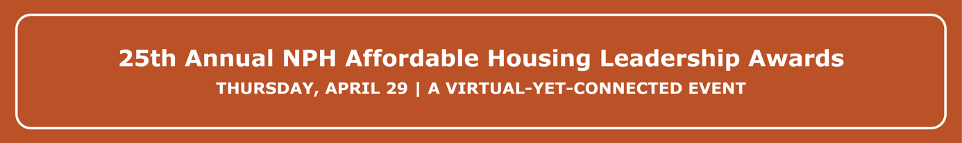

2021 NPH Awards Sponsorship Form

Guest List Deadline: Wednesday, April 21 at 5pm PST.
Sponsors guest names and emails will need to be submitted on or before Wednesday, April 21 at 5pm PST. Guests who are no longer able to attend may transfer their ticket to another person. Substitutions will be accepted until Wednesday, April 21 at 5pm PST. This will ensure that all guests will receive the necessary instructions and links to access the virtual event. To make changes to your guest list, please email hilda@nonprofithousing.org.
Emails
To communicate Fall Gala related announcements and updates, including instructions and links to access the virtual event, your guests and yourself will be added to our email list and will receive a welcome email. This only applies to those who are not currently in our email list. You may edit your subscription setting at any time.
Check out our matrix to view different sponsor levels and benefits! https://nonprofithousing.org/wp-content/uploads/2021/02/2021-Awards-Sponsor-Matrix.pdf
For all other questions please contact Morgan@nonprofithousing.org.
A receipt of this form will be sent to the email address listed below. Please bookmark the receipt for quick access.
* Required

Email address *
Your email

Please complete this form only if you are paying by check or requesting an invoice. For ONLINE PAYMENTS, click here: https://nphdonations.secure.force.com/NPHEvents/CnP_PaaS_EVT__ExternalRegistrationPage?event_id=a1z6f000006rZXVAA2&

Sponsor level: *
- $500 - Friendly Neighbor (includes 2 ticket)
- $1,000 - Groundbreaker (includes 4 tickets)
- $2,500 - Community Pillar (includes 5 tickets)
- $5,000 - Community Voice (includes 6 tickets)
- $10,000 - Visionary (includes 8 tickets)
- $20,000 - Underwriter (includes 10 tickets)
- $40,000 - Legacy Leadership Partner (includes 12 tickets)

Payment Type: *
- Invoice (our accountant will email an invoice within 3 business days)
- Check (made out to "NPH"). Temporary Address: NPH, Attn. Hilda Morones, 2544 Sutter St, San Francisco, CA 94115
- Sponsorship exchange with NPH
- Other:

Contact Information
Organization/Employer Name: * Employer name as you would like it listed on promotional materials.

Sponsorship primary contact: First Name *
Sponsorship primary contact: Last Name *
Sponsorship primary contact: Email *
Sponsorship primary contact: Phone Number *
Sponsorship primary contact: Address *
Billing Contact (if different from above)
Billing Contact: Full Name
Billing Contact: Email
Billing Contact: Phone Number
Additional comments:

Sponsored Guest List
As an event sponsor, you receive complimentary tickets. If available, please provide the names and emails of your guests. If your guest list is unconfirmed, you may skip this section and provide names at a later time.
- $500 - Friendly Neighbor (includes 2 ticket)
- $1,000 - Groundbreaker (includes 4 tickets)
- $2,500 - Community Pillar (includes 5 tickets)
- $5,000 – Community Voice (includes 6 tickets)
- $10,000 - Visionary (includes 8 tickets)
- $20,000 - Underwriter (includes 10 tickets)
- $40,000 - Legacy Leadership Partner (includes 12 tickets)

Attendee #1 - Full Name:
Attendee #1 - Email:
Attendee #2 - Full Name:
Attendee #2 - Email:
Attendee #3 - Full Name:
Attendee #3 - Email:
Attendee #4 - Full Name:
Attendee #4 - Email:
Attendee #5 - Full Name:
Attendee #5 - Email:
Attendee #6 - Full Name:
Attendee #6 - Email:
Attendee #7 - Full Name:
Attendee #7 - Email:
Attendee #8 - Full Name:
Attendee #8 - Email:
Attendee #9 - Full Name:
Attendee #9 - Email:
Attendee #10 - Full Name:
Attendee #10 - Email:
Attendee #11 - Full Name:
Attendee #11 - Email:
Attendee #12 - Email:
Attendee #12 - Full Name:

Confirmation
Promise to Pay Agreement *
I agree and promise to pay the selected amount before Monday, May 31 2021.
- I agree.
First and Last Name: *
Employer: *
Title: *
Email: *

Please submit completed form to
Morgan@nonprofithousing.org

