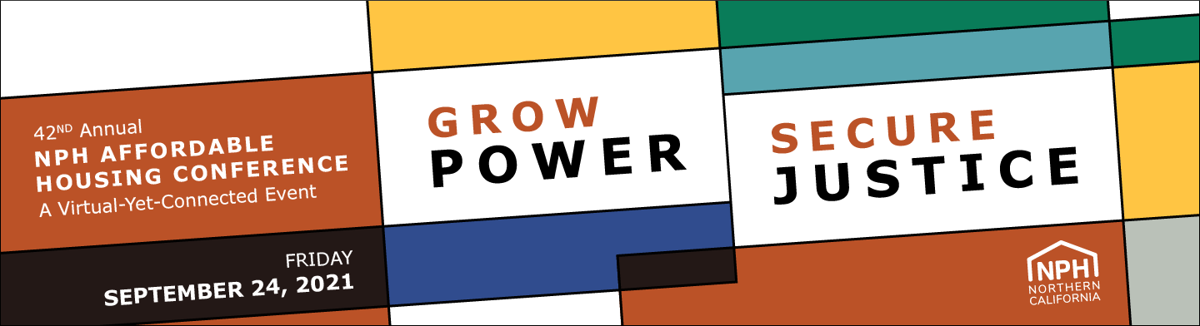

2021 NPH Conference Sponsorship - Check/Invoice Request Form

We can not do this work without your generous sponsors and your support is more important than ever.

Your sponsorship goes beyond our event and directly sustains our work as we pivot our work to address emerging challenges and continue to respond to member needs. As we turn to a virtual event, we are offering new and creative ways to spotlight our event sponsors in an online space.

Important Deadlines
For planning purposes, some of our sponsor benefits have deadlines. Please sponsor by the following dates to secure the corresponding benefit and to maximize your sponsorship!

August 20: Social media commercial (eligible for sponsors at the $20K level or above)
August 20: Day-of speaking role (eligible for sponsors at the $50K level or above)
September 3: Interactive virtual exhibitor booth (eligible for sponsors at the $3K level or above)
September 3: Stage acknowledgment (eligible for sponsors at the $35K level or above)
September 3: Email visibility (eligible for sponsors $5K level and above)
September 3: Social Media visibility (eligible for sponsors $10K level and above)
September 14: Virtual site listing (eligible for all sponsors)
September 14: Sponsored guest list (eligible for all sponsors)
September 17: Website visibility (eligible for all sponsors)
September 17: Chatbox visibility (eligible for sponsors $10K level or above)

For questions please contact Morgan@nonprofithousing.org.

*Required

Email *

For ONLINE PAYMENTS, click here: https://nphdonations.secure.force.com/NPHEvents/CnP_PaaS_EVT__ExternalRegistrationPage?event_id=a1z6f0000076zJfAAI

Sponsor level: *
- $500 - Supporter (includes 2 tickets)
- $1,500 - Donor (includes 4 tickets)
- $3,000 - Sustainer (includes 5 tickets)
- $5,000 - Benefactor (includes 6 tickets)
- $10,000 - Community Builder (includes 8 tickets)
- $20,000 - Underwriter (includes 10 tickets)
- $35,000 - Movement Partner (includes 12 tickets)
- $50,000+ - Legacy Leadership Partner (includes 20 tickets)

Payment Type: *
- Invoice (our accountant will email an invoice within 3 business days)
- Check (made out to "NPH"). Temporary Address: NPH, Attn. Hilda Morones, 2544 Sutter St, San Francisco, CA 94115

Contributions to NPH are tax-deductible as allowable by law, less $50 per free or purchased pass. NPH is a 501(c)(3) tax-exempt organization: #94-2741597.

_________________________________________________________________________________

Contact Information
The sponsorship primary contact will be our lead contact for guest list coordination and exhibitor booth coordination for those sponsoring a the $3,000 and above level.

Organization/Employer Name: *
Employer name as you would like it listed on promotional materials.

Sponsorship primary contact: Full Name *
Sponsorship primary contact: Work Email *
Sponsorship primary contact: Work Phone Number *

Billing Contact (if different from above)
Billing Contact: Full Name
Billing Contact: Work Email
Billing Contact: Work Phone Number

Exhibitor Contact (if different from above) Only for $3K and above sponsors

Exhibitor Contact: Full Name
Exhibitor Contact: Work Email
Exhibitor Contact: Work Phone Number
Additional comments:

_________________________________________________________________________________

Sponsored Guest List
As an event sponsor, you receive complimentary tickets. If available, please provide the names and emails of your guests. If your guest list is unconfirmed, you may skip this section and provide names at a later time.

Please note that final guest names need to be confirmed before September 14 at 5pm PDT.
To skip this section, scroll to the bottom of the page.

$500 - Supporter (includes 2 ticket)
$1,500 - Donor (includes 4 tickets)
$3,000 - Sustainer (includes 5 tickets)
$5,000 - Benefactor (includes 6 tickets)
$10,000 - Community Builder (includes 8 tickets)
$20,000 - Underwriter (includes 10 tickets)
$35,000 - Movement Partner (includes 12 tickets)
$50,000+ - Legacy Leadership Partner (includes 20 tickets)

Attendee #1 - Full Name:
Attendee #1 - Email:
Attendee #2 - Full Name:
Attendee #2 - Email:
Attendee #3 - Full Name:
Attendee #3 - Email:
Attendee #4 - Full Name:
Attendee #4 - Email:
Attendee #5 - Full Name:
Attendee #5 - Email:
Attendee #6 - Full Name:
Attendee #6 - Email:
Attendee #7 - Full Name:
Attendee #7 - Email:
Attendee #8 - Full Name:
Attendee #8 - Email:
Attendee #9 - Full Name:
Attendee #9 - Email:
Attendee #10 - Full Name:
Attendee #10 - Email:
Attendee #11 - Full Name:
Attendee #11 - Email:
Attendee #12 - Full Name:
Attendee #12 - Email:
Attendee #13 - Full Name:
Attendee #13 - Email:
Attendee #14 - Full Name:
Attendee #14 - Email:
Attendee #15 - Full Name:
Attendee #15 - Email:
Attendee #16 - Full Name:
Attendee #16 - Email:
Attendee #17 - Full Name:
Attendee #17 - Email:
Attendee #18 - Full Name:
Attendee #18 - Email:
Attendee #19 - Full Name:
Attendee #19 - Email:
Attendee #20 - Full Name:
Attendee #20 - Email:

_________________________________________________________________________________

Confirmation
Promise to Pay Agreement *
I agree and promise to pay the selected amount before Friday, October 15. Note: This excludes those who have already paid earlier this year with NPH bundled ask.
- I agree to pay.

First and Last Name: *
Employer: *
Title: *
Email: *

Please submit this completed form to Morgan@nonprofithousing.org

