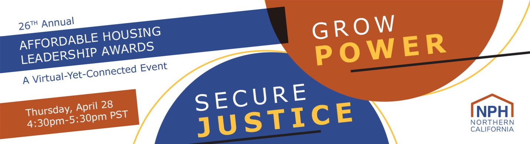

2022 NPH Awards: Tickets Invoice/Check Request form
Cancellation/Refund Deadline: Wednesday, April 20 at 5pm PT.
Registrants canceling their registration on or before Wednesday, April 20 at 5pm PT will receive a full refund. Refund requests submitted after the deadline are not guaranteed and will be reviewed on an individual basis for extenuating circumstances. To submit a refund request, please email morgan@nonprofithousing.org.
Substitution Deadline: Wednesday, April 20 at 5pm PT.
Registrants who are no longer able to attend may transfer their ticket to another person. Substitutions will be accepted until Wednesday, April 20 at 5pm PT. This will ensure that all guests will receive the necessary instructions and links to access the virtual event. To substitute tickets or edit your guest list, please email morgan@nonprofithousing.org.
Emails
To communicate Leadership Awards related announcements and updates, including instructions and links to access the virtual event, your guests and yourself will be added to our email list and will receive a welcome email. This only applies to those who are not currently in our email list. You may edit your subscription setting via newsletter emails at any time.
For all other questions please contact Morgan@nonprofithousing.org.

* Required

Email *

Please complete this form ONLY if you are paying for tickets by check or are requesting an invoice. To check your membership status, contact Daniel@nonprofithousing.org For ONLINE PAYMENTS, click here: https://nphdonations.secure.force.com/NPHEvents/CnP_PaaS_EVT__ExternalRegistrationPage?event_id=a1z6f000006PRl7AAG

How many tickets are you purchasing? *

Type of ticket(s) you are purchasing: *
Questions about your NPH membership? Please email daniel@nonprofithousing.org. Please choose all that apply.
- $75 - Member Ticket
- $100 - Non-Member Ticket
- N/A - Unable to attend, but I would like to make a donation to NPH
- Other:

Add a donation!
Your donation directly supports and sustains NPH. With your support, together we can continue to secure new resources for affordable housing through our policy work at the local, regional, and state-level; grow the affordable housing movement through our advocacy work; strengthen our industry by offering much-needed trainings; and ensure an equitable recovery that prioritizes antiracist housing policies and solutions.
- $25
- $50
- $100
- $250
- $500
- $750
- $1,000
- Other:

Is this ticket purchase and/or donation on behalf of your organization? *
- Yes
- No

Is it okay to acknowledge your donation in our NPH materials? *
- Yes, you can share my name in NPH materials (e.g. emails and NPH website).
- No, please keep my donation anonymous

Payment Type: *
Invoice (our accountant will email an invoice within 3 business days)
Check (made out to "NPH"): 369 Pine Street, Suite 350 San Francisco, CA 94104

Payment Total *

Contact Information
Organization/Employer Name: *

Primary contact: First Name *

Primary contact: Last Name *

Primary contact: Email *

Primary contact: Phone Number *

Primary contact: Address *

Billing Contact (if different from above)
Billing Contact: Full Name

Billing Contact: Email

Billing Contact: Phone Number

Billing Contact: Address

Additional comments:

Attendee Information
Note: Each attendee MUST include a valid email address.
To make changes, please email Morgan@nonprofithousing.org before Wednesday, April 20 at 5pm PT.
Attendee #1 - Full Name:

Attendee #1 - Email:

Attendee #2 - Full Name:

Attendee #2 - Email:

Attendee #3 - Full Name:

Attendee #3 - Email:

Attendee #4 - Full Name:

Attendee #4 - Email:

Attendee #5 - Full Name:

Attendee #5 - Email:

Attendee #6 - Full Name:

Attendee #6 - Email:

Attendee #7 - Full Name:

Attendee #7 - Email:

Attendee #8 - Full Name:

Attendee #8 - Email:

Attendee #9 - Full Name:

Attendee #9 - Email:

Attendee #10 - Full Name:

Attendee #10 - Email:

Attendee #11 - Full Name:

Attendee #11 - Email:

Attendee #12 - Email:

Attendee #12 - Full Name:

Confirmation
Promise to Pay Agreement *
I agree and promise to pay the selected amount before May 30, 2022.
- I agree.

First and Last Name: *

Employer: *

Title: *

Email: *

Date: *

Thank you for your ticket purchase! Please submit this form to Morgan@nonprofithousing.org by Friday, April 15

We look forward to seeing you on April 28!

Invoices will be emailed within 3 business days.

Checks should be made out to: NPH
And mailed to:
Check (made out to "NPH"): 369 Pine Street, Suite 350 San Francisco, CA 94104

For any ticket or billing questions, please contact morgan@nonprofithousing.org
For any marketing or sponsor questions, please contact estephanie@nonprofithousing.org

