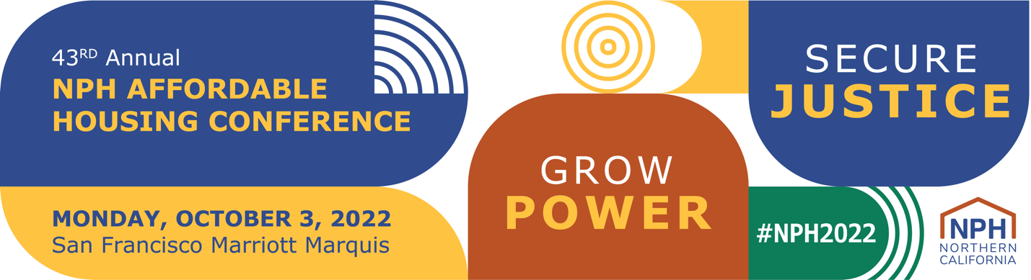

2022 NPH Conference Sponsorship Form
We cannot do this work without your generous sponsors and your support is more important than ever.
Your sponsorship goes beyond our event and directly sustains our work as we pivot our work to address emerging challenges and continue to respond to member needs. As we move to an in-person event, we are offering new and returning ways to spotlight our event sponsors in a physical space.
Important Deadlines
For planning purposes, some of our sponsor benefits have deadlines. Please sponsor by the following dates to secure the corresponding benefit and to maximize your sponsorship!
June 24: Logo listing on conference bags (eligible for sponsors at the $20K level or above)
August 19: Speaking opportunity (eligible for sponsors at the $50K level or above)
August 19: Exhibitor booth (eligible for sponsors at the $3K level or above)
August 19: Listing on program (name only; logo listing eligible for sponsors at the $5K level or above)
September 12: Stage acknowledgment (eligible for sponsors at the $35K level or above)
September 12: Social media acknowledgment (eligible for sponsors $10K level and above)
September 12: Email acknowledgment (eligible for sponsors $5K level and above)
September 12: Tickets (eligible for all sponsors)
September 12: Signage listing (name only; logo listing eligible for sponsors at the $5K level or above)
September 23: Website listing (name only; logo listing eligible for sponsors at the $5K level or above)
September 23: Listing on stage screen (name only; logo listing eligible for sponsors at the $5K level or above)
For questions please contact Andrew@nonprofithousing.org.
Emails
To communicate Conference related announcements and updates, your guests and yourself will be added to our email list and will receive a welcome email. This only applies to those who are not currently in our email list. You may edit your subscription setting at any time.
Check out our matrix to view different sponsor levels and benefits! https://nonprofithousing.org/wp-content/uploads/2022/05/NPH-Conference-benefits-matrix.pdf
For all other questions please contact Andrew@nonprofithousing.org.
Please complete this form only if you are paying by check or requesting an invoice.
For ONLINE PAYMENTS, click here:
https://nphdonations.secure.force.com/NPHEvents/CnP_PaaS_EVT__ExternalRegistrationPage?event_id=a1z6f000006PShWAAW
*Required

Submit this completed form to Andrew@nonprofithousing.org by Friday, October 15

Sponsor level: *
- $500 – Supporter (includes 1 ticket)
- $1,500 - Donor (includes 2 tickets)
- $3,000 - Sustainer (includes 3 tickets)
- $5,000 - Benefactor (includes 4 tickets)
- $10,000 - Community Builder (includes 6 tickets)
- $20,000 - Underwriter (includes 8 tickets)
- $35,000 - Movement Partner (includes 10 tickets)
- $50,000 - Legacy Leadership Partner (includes 20 tickets)

Payment type: *
- Invoice (our accountant will email an invoice within 3 business days)
- Check (made out to “NPH”). Address:
NPH, Attn. Belinda Kemetse
369 Pine St, Ste 350
San Francisco, CA 94104

Contact Information
Organization/Employer Name: * Employer name as you would like it listed on promotional materials.

Sponsorship primary contact: First Name *

Sponsorship primary contact: Last Name *

Sponsorship primary contact: Email *

Sponsorship primary contact: Phone Number *

Sponsorship primary contact: Address *

Billing Contact (if different from above):
Billing Contact: Full Name

Billing Contact: Email

Billing Contact: Phone Number

Exhibitor Contact (if different from above) (only for $3K and above sponsors):
Are you interested in an exhibitor booth? Y / N

If yes:
Exhibitor Contact: Full Name

Exhibitor Contact: Work Email

Exhibitor Contact: Work Phone

Additional comments:

Invoice
By filling out this form, our accountant will send the billing contact an invoice for the selected sponsorship level and amount.
Checks (made out to "NPH") can be mailed to the NPH office (369 Pine Street Suite 350 San Francisco, CA 94104).

Contributions to NPH are tax-deductible as allowable by law, less $340 per free or purchased pass. NPH is a 501(c)(3) tax-exempt organization: #94-2741597.

Confirmation
Promise to Pay Agreement *I agree and promise to pay the selected amount before Friday, October 15, 2022.

- I agree.

NPH Conference Agreement * By sponsoring the event, you agree to adhere to all deadlines and policies of the conference.

- I will comply to conference policies.

First and Last Name: *

Employer: *

Title: *

Email: *

Submit this completed form to Andrew@nonprofithousing.org by Friday, October 15

